**PRACTICAL-4**

**fs(file system) – core module of Node.js**

1. **Create a file named ‘file1.txt’ and write a list of comma-separated numbers in it, such as 10, 20, 30, 40. Implement a function that reads the content of file1.txt file using the fs module and calculates the following statistics:**
   1. **The sum of all numbers.**
   2. **The average of all numbers.**
   3. **The maximum and minimum numbers.**
   4. **Display the calculated statistics in the console.**

const fs = require('fs');

const Numbers = '13, 22, 3, 4, 58';

fs.writeFile('file1.txt',Numbers,(err) => {

if(err){

console.error("Error in Creating File:",err);

}

else{

fs.readFile('file1.txt','utf8',(err,data) => {

console.log("File Readed Successful.");

const numberArray = data.split(',').map(Number);

let sum = 0;

for(let i in numberArray){

sum = sum + numberArray[i];

}

const avg = sum / numberArray.length;

const min = Math.min(...numberArray);

const max = Math.max(...numberArray);

console.log("Addition : ",sum);

console.log("Average : ",avg);

console.log("Min. : ",min);

console.log("Max. : ",max);

});

}

});

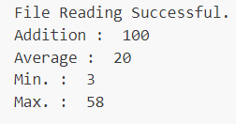

1. **Create a module “TextProcessing” contain functions named countWords, countLines, countCharacters which takes a string as input from ‘file2.txt’ file and returns the total number of words, lines and characters in the console.**

**App.js :**

let fs = require('fs');

let TextProcessing = require('./TextProcessing');

fs.readFile('file2.txt','utf8',(err,data)=>{

if(err){

console.log("Error in File Reading.:",err);

}

else{

let words = TextProcessing.countWords(data);

let lines = TextProcessing.countLines(data);

let characters = TextProcessing.countCharacters(data);

console.log('Total Words: ',words);

console.log('Total Lines: ',lines);

console.log('Total Characters: ',characters);

}

});

**TextProcessing.js :**

let TextProcessing = {

countWords: function (txt) {

let words = txt.split(/\+s/).filter(Boolean);

return words.length;

},

countLines: function (txt) {

let lines = txt.split('/n').filter(Boolean);

return lines.length;

},

countCharacters: function (txt){

let characters = txt.length;

return characters;

}

};

module.exports = TextProcessing;

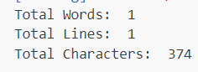

1. **Differentiate between synchronous and asynchronous file operations with an example.**

const fs = require('fs');

console.log('210120210003_AMIT GOSWAMI');

try{

var syncData1 = fs.readFileSync('file1.txt', 'utf8');

var syncData2 = fs.readFileSync('file2.txt', 'utf8');

}

catch(err){

console.error('Error reading file asynchronously:', err);

}

console.log('Synchronous file read:');

console.log(syncData1);

fs.readFile('file1.txt', 'utf8', (err,Data) => {

if(err){

console.error('Error reading file asynchronously:', err);

}

else{

console.log('\nAsynchronous file read:');

console.log(Data);

}

});

console.log('Synchronous file read:');

console.log(syncData2);

fs.readFile('file2.txt', 'utf8', (err,Data) => {

if(err){

console.error('Error reading file asynchronously:', err);

}

else{

console.log('Asynchronous file read:');

console.log(Data);

}

});

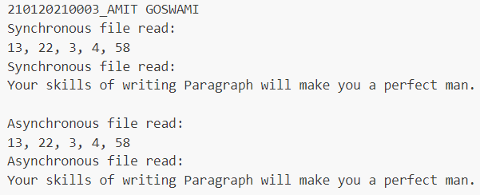

1. **Create a file named search.txt and write some text content in it, including a specific word. Implement a function that takes a search term as input and searches for occurrences of that term in the search.txt file using the fs module. Display the line numbers and positions of all occurrences of the search term in the console.**

const fs = require("fs");

console.log("21012021003_AMIT GOSWAMI");

function searchForTerm(searchTerm) {

fs.readFile("search.txt", "utf8", (err, data) => {

if (err) {

console.error("Error reading file:", err);

}

else {

const lines = data.split("\n");

let lineNum = 1;

console.log(`Occurrences of "${searchTerm}" in search.txt:`);

for (let i = 0; i < lines.length; i++) {

const line = lines[i];

let pos = line.indexOf(searchTerm);

while (pos !== -1) {

console.log(`Line ${lineNum}, Position ${pos + 1}`);

pos = line.indexOf(searchTerm, pos + 1);

}

lineNum++;

}

}

});

}

searchForTerm("writing");

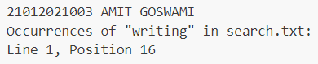

1. **Create a Node.js script that generates an HTML file (dynamic.html) dynamically. The HTML file should contain a table with data from an array of objects. Each object represents a person with properties like name, age, and city. Display the data in the table and style it with CSS.**

const fs = require('fs');

const people = [

{ name: 'Amit', age: 20, city: 'New York' },

{ name: 'Vishal', age: 19, city: 'Los Angeles' },

{ name: 'Reet', age: 22, city: 'Chicago' },

];

function generateHTML(people) {

let htmlContent = `

<!DOCTYPE html>

<html>

<head>

<title>Dynamic HTML Table</title>

<style>

/* Add CSS styles here to style the table */

table {

border-collapse: collapse;

width: 80%;

margin: auto;

}

th, td {

border: 1px solid black;

padding: 8px;

text-align: center;

}

th {

background-color: #f2f2f2;

}

</style>

</head>

<body>

<h1>People Data</h1>

<table>

<tr>

<th>Name</th>

<th>Age</th>

<th>City</th>

</tr>

`;

for (const person of people) {

htmlContent += `

<tr>

<td>${person.name}</td>

<td>${person.age}</td>

<td>${person.city}</td>

</tr>

`;

}

// Complete the HTML content

htmlContent += `

</table>

</body>

</html>

`;

return htmlContent;

}

const dynamicHTMLContent = generateHTML(people);

fs.writeFile('dynamic.html', dynamicHTMLContent, (err) => {

if (err) {

console.error('Error writing to dynamic.html:', err);

} else {

console.log('dynamic.html created successfully!');

}

});

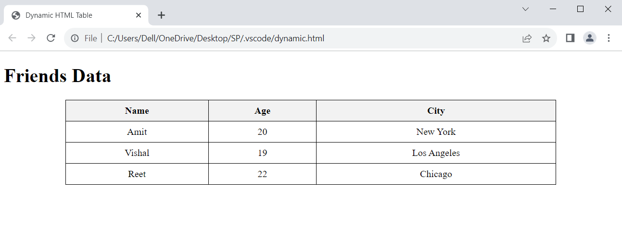

1. **Perform basic file operations:**
   1. **Rename the existing file with the new name and display system’s error’s message if it doesn’t exist.**

const fs = require('fs');

currentFileName = 'exfg.txt';

newFileName = 'MyFile.txt';

fs.rename(currentFileName, newFileName, (err) => {

if (err) {

if (err) {

console.error(`The file '${currentFileName}' does not exist.`);

} else {

console.error('Error occurred while renaming the file:', err);

}

} else {

console.log(`File '${currentFileName}' has been renamed to '${newFileName}'.`);

}

});



* 1. **Delete the existing file and display system’s error’s message if it doesn’t exist.**

const fs = require('fs');

const fileNameToDelete = 'MyFile.txt';

fs.unlink(fileNameToDelete, (err) => {

if (err) {

if (err) {

console.error(`The file '${fileNameToDelete}' does not exist.`);

} else {

console.error('Error occurred while deleting the file:', err);

}

} else {

console.log(`File '${fileNameToDelete}' has been deleted.`);

}

});



* 1. **Copy file into different directory.**

const fs = require('fs');

const sourceFilePath = './file2.txt';

const destinationDirectory = './Copyfile.txt';

fs.copyFile(sourceFilePath, `${destinationDirectory}`, (err) => {

if (err) {

console.error('Error occurred while copying the file:', err);

} else {

console.log(`File '${sourceFilePath}' has been successfully copied to '${destinationDirectory}'.`);

}

});





* 1. **Create and remove directory.**

const fs = require('fs');

const directoryPathToRemove = 'C:/Users/HP/OneDrive/Desktop/SP/Practical_4/DirToRemove';

fs.rmdir(directoryPathToRemove, { recursive: true }, (err) => {

if (err) {

console.error('Error occurred while removing the directory:', err);

} else {

console.log(`Directory '${directoryPathToRemove}' has been successfully removed.`);

}

});



* 1. **Append content in file.**

const fs = require('fs');

const filePath = './Copiedfile.txt';

const contentToAppend = '\n This is the content to append to the file.\n';

fs.appendFile(filePath, contentToAppend, (err) => {

if (err) {

console.error('Error occurred while appending content to the file:', err);

} else {

console.log('Content has been successfully appended to the file.');

}

});



